if u want to upload war file to nexus repository you need to

1.setup a nexus server first as follows

*create vm with aerospike/centos-6.5
*then sudo -i
* yum install -y java-1.8.0-openjdk.x86_64
* install vim and wget
*yum install -y java-1.8.0-openjdk-devel.x86_64
*export RUN_AS_USER=root
*wget http://www.sonatype.org/downloads/nexus-latest-bundle.tar.gz
* sudo cp nexus-latest-bundle.tar.gz /usr/local/
* cd /usr/local
* sudo tar xvzf nexus-latest-bundle.tar.gz
* sudo ln -s nexus-2.13.0-01 nexus
* change port in /usr/local/nexus/conf/nexus.properties
* /usr/local/nexus/bin/nexus start

2.set up in jenkins as follows:

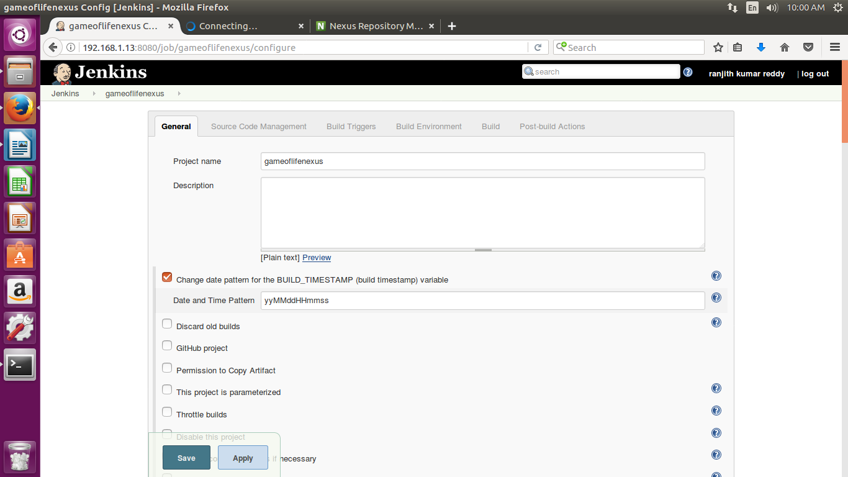
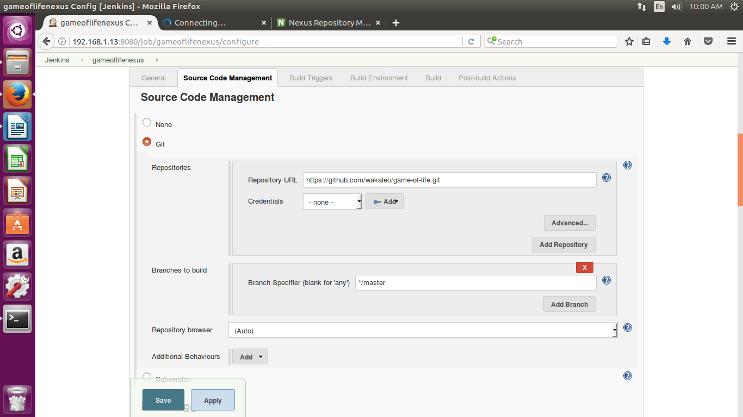
then

then: here you must give nexus server’s vm ip address and nexus user as admin and pwd: admin123

groupid:any name you can

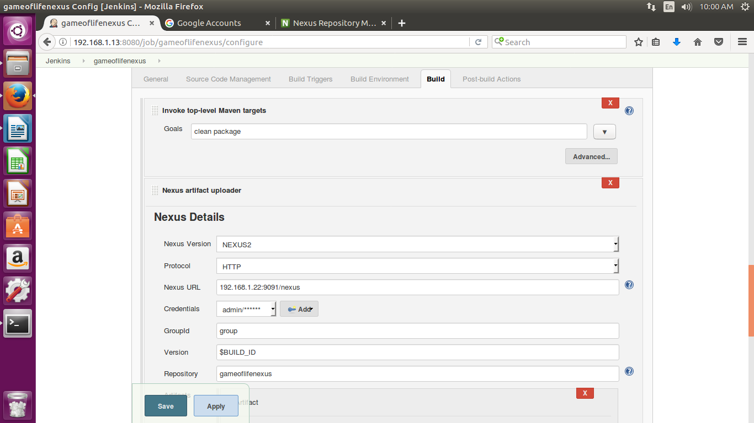

then

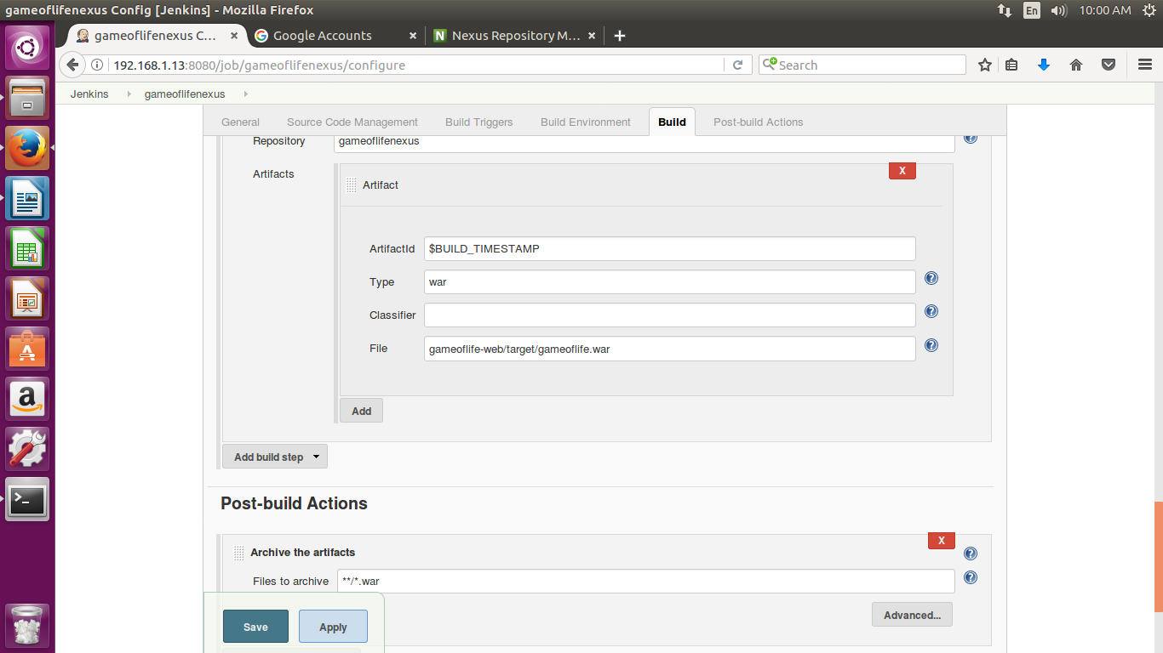

then
